**Options**

**European (exercise only at expiration)**

**American (exercise whenever before the expiration)**

**Balck-Scholes-Merton**

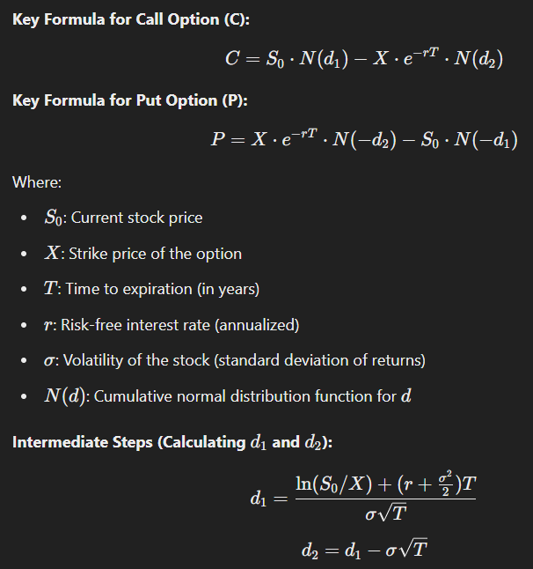

**Binomial Model**